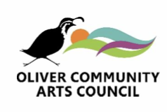
INTERNAL USE ONLY
Date approved:

File # ________________
PO Box 1711
Oliver BC. V0H 1T0
OliverCAC@gmail.com
OliverArtsCouncil.org

ART LEARNED ART LOVED ART LIVED

ARTS IN ACTION GRANT APPLICATION FORM – PART 2
To be submitted upon completion of your event.

Name of Organization
Cheque “payable to” if different
Mailing Address
Contact Person:
Phone: |  | Email:

- Please complete the following and return to the address above, marked “Attention: Treasurer”.

Amount applied for in Part 1 | $ | File # (refer to confirmation email)

- Please attach an actual profit and loss (income) statement listing both your revenue and expenses for the event. Please ensure copies of receipts are attached. If you have questions or require assistance with your income statement completion, please feel free to contact our treasurer at Olivercac@gmail.com.

- Please attach copies of any material that demonstrates the event took place and has acknowledged the OCAC.

Reviews News Articles Advertising
Photos Programs Other ___________________

Group Representative Name: (please print)
Group Representative Signature  (typed name implies signature) | Date:

(INTERNAL USE ONLY)
Amount of Funds Provided _______________________. Cheque # _________________ Date of Issue ____________________________

