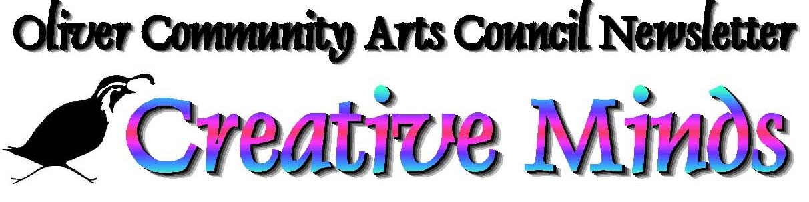
June 2010

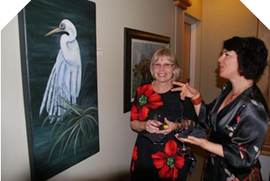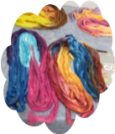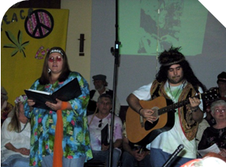
Oliver SageBrushers Linda Blaschuk & Corinne Desampaio Desert Sage Guild silk Sage Valley Voices ‘House of the Rising Sun’ s
Burrowing Owl Winery ‘Art at the Owl’ Show & Sale in April dyeing workshop singers from April 24/25 concert

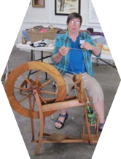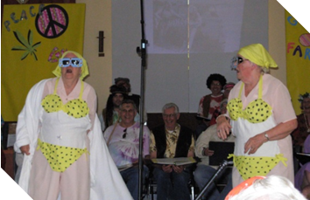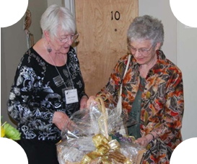
Helene Godin spinning silk Sage Valley Voices Itsy Teeny Yellow Polka Dot Bikinis Sally Franks presents Evie New a gift basket
for her winning 2010 Fall Art Show poster

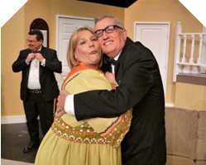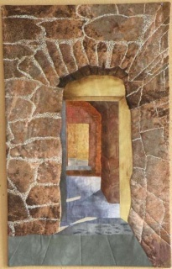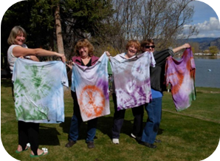
SOAP’s production of Rumors by Neil Simon Dianne Birnie’s quilt ‘The Corridor’ 60’s Music to Tie-Dye for


Arts Jam is a monthly gathering of the membership of the Oliver Community Arts Council for arts news and views. Meet our board and directors: Esther Brown, Penelope Johnson, Penny Ruddy, Jack Bennest, Sally Franks, Darryl Mackenzie, Jennifer Mapplebeck, Brian Mapplebeck, Shirley Nillson, Hella Prochaska, Craig Rusinek and Steve Staresina. They represent a good cross-section of business and non-profit groups and have a variety of artistic interests as well as administrative skills. Everyone is welcome!
Arts Jams: June 21 @ 6:00 pm for a Barbecue
July 26 @ 9:30 am
August 23 @ 9:30 am
September 27 @ 9:30 am
Where: Quail’s Nest Arts Centre, 34274 – 95 Street, Oliver.

by Marion Boyd
The South Okanagan Concert Society has now signed contracts with musicians of exceptional talent to perform in our 2010-2011 series. Entirely flexible passes for all four concerts are on sale at Miss Molly’s Quilt Shoppe in Oliver and at Imperial Office Pro in Osoyoos for $60.00. Single tickets, available at the door, are $20 each. Those 17 and under are free.
Thursday, October 14: Andi & Peter Alexander with “Opera Spice and Everything Nice”.
Fabulous song and crazy antics will make for a fun filled evening.
Friday, November 19: Daniel Gervais with his lively fiddle music and Aline Dupuis with
her step dancing will have you tapping your toes.
Friday, January 14: Sara Buechner is a dazzling concert pianist and witty speaker
with a gregarious personality.
February: The Foothills Brass Quintet will return with their off key humour and
amazing musical talent.
All concerts are at the Venables Auditorium at the High School in Oliver and start at 8:00 pm.
Do come and join us!
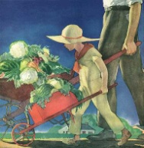

“THOSE WERE THE DAYS” is the theme chosen for the 27th annual Fall Art Show & Sale October 2 and 3, 2010. The Oliver community Arts Council has been planning this year’s event with inspiration drawn from the Oliver & District Heritage Society. See insert with this newsletter for information and registration form.
Museum director Darryl Mackenzie is thrilled about the collaboration between the two organizations on the art show. For him, art and history are a natural pairing. The Oliver Arts Council intends the theme to be general enough to inspire the widest possible creativity. The show accepts entries from all media including painting, photography, fibre arts, mixed media and three dimensional including sculpture, leather work, pottery, woodwork, jewelry, metalwork and other objets d’art. A special category, ‘Emerging Artists’, encourages submissions from youth 19 and under.
The Fall Art Show & Sale is held in conjunction with the Festival of the Grape and includes live jazz music, a classy silent auction, refreshments and exhibits of artists at work.
“SOMETHING OLD BECOMES SOMETHING NEW”
Downsizing? Cleaning out your attic? Keep an eye out for any collectibles or small antique items you might like to donate to the arts council. With our Fall Art Show and Sale this Fall we are holding a silent auction that will feature small collectibles and antiques donated by members.
Think objects d’art, 1950s Tonka toys, pioneer crafts and tools, baseball cards, china or silverware items. Items need to be in good repair and saleable. We are hoping for items with a story to tell. We will do the writing and include the story as part of the item up for auction.
To donate or for assistance in choosing an item call Arvie Bourgeault at 250-498-6552.

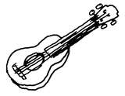

The Arts Council is pleased to present a Bluegrass Coffee House concert on Thursday, June 17 at 7:00 pm at the Quail’s Nest Arts Centre. Two to three bands will be a-pluckin’ and a-strummin’ on banjos, guitars and mandolins so come on down and join the finger-pickin’ fun!
Admission is $10.00 with coffee, tea and goodies available.

by Heather Fink
Music in the Park runs from July 8th to August 26th, 2010 each Thursday at 6:30 pm on the east side of Oliver’s CPR Station/Visitors Centre

This year the ‘Desert Airs Men’s Chorus’ and the ‘Nouveau’ trio of Lori & Chris Stodola and Ray Renaud will kick off our outdoor concert series July 8th. Each Thursday evening will feature a rich diversity of music including old-time favourites, country, rock, pop and jazz, with a little classical and ethnic music thrown in for good measure. These events will showcase some of the wonderfully talented musicians and vocalists, young and old, who live in the South Okanagan.
Admission is free although a suggested minimum donation of $3.00 per concert will be much appreciated. Bring your family, friends and neighbours, a lawn chair or blanket, and enjoy the shows!

by Sally Franks: 250-498-0104
The Oliver Sagebrushers meet every Tuesday from 8:45 to 12 noon, September through June at the Quail’s Nest Arts Centre, 34274 – 95th Street. Membership fee is $50.00 per year
(or $25 in September and $25 in January)
Oliver Sagebrushers in conjunction with the Oliver Arts Council held ‘Art at the Owl’ during Arts & Culture Week in April. It was highly successful with paintings and three dimensional creations sold. The reception was attended by 150 people with another 200 attending during the week.
We are winding down now for the summer with Plenn-aire painting during June. Val Friesen will host our final club event ‘Clothesline Painting’ in June at his home for our annual potluck prior to a break for summer holidays. Drop in to the Quail’s Nest Arts Centre June 11–26 to view our works form the past club season.
One more workshop will be held before our Summer break however. Robert Wood from Calgary will be demonstrating Oil Painting June 30 and July 1. The cost for the workshop is $150 for the two days. If you wish to participate please call Sally at 250-498-0104.8-2708.

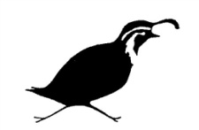
The long running Summer Studio program has been shelved for 2010, after cutbacks in funding for the arts this past year. However, there is still plenty to see and do at the Quail’s Nest! Four groups have booked the venue to mount fascinating demonstrations, colourful exhibits and great sales. Be sure to drop in on the following dates:
Monday, June 28 – Saturday, July 3: The Ripoff Artists
So named for their annual pilfering of a famous dead artist’s masterpiece, this year the Ripoff Artists will scale to new heights in lifting Lawren Harris’s ‘Mount Lefroy’. Lawren was the driving force behind the formation of the Canadian ‘Group of Seven’ and was pivotal in the development of a uniquely Canadian style of landscape painting. Our ‘Group of Nine’ artists include fibre by Terry Irvine, collage by Marion Trimble, quilters Dianne Birnie & Enid Baker, fine artist JoAnn Turner, 3-dimensional artist Kurt Hutterli, weaver Barbara Levant, encaustic artist Thea Haubrich, photographer Russell Work and guest woodworker Leo Pedersen.
Come and join us for a reception June 28 from 6-8 pm and during the week from 9 am to 3 pm.
Monday, July 5 – Saturday, July 10: Desert Sage Spinners & Weavers
Come see us at the Quail’s Nest in Oliver to view our activities. If you are interested in joining an exciting and enthusiastic group for comraderie or to learn a new art utilizing fibre – weaving, spinning, felting, dyeing or knitting, this is the group to join. We have experienced members to help you with your projects and a well stocked library with equipment and books.
Monday, July 12 – Saturday, July 17: Oliver SageBrushers
Friday, July 23 – Sunday, 25: Artisans Market (Nature’s Elements Jewelry & Friends)
Come to view and purchase handmade items from the Okanagan Valley and surrounding area. Are you interested in becoming a vendor? We are looking for artists and artisans who make beautiful pieces in all sorts of mediums: quilting, painting, collage, woodworking, furniture making, house and garden décor, photography, print making, fabric art, musical instruments, weaving, sketching, pottery, jewelry, baking …………. We will also host a silent auction.
Can you provide entertainment? We are looking for acoustic instrumentalists and vocalists.
Please contact Deanna at 250-487-9663 or email for more information:
Natures.elements.jewelry@gmail.com


The Oliver Library web site: www.orl.bc.ca
Membership is $5.00 adults / $3.00 students & seniors. For further information contact:
Friends of the Oliver Library, Box 758, Oliver, B.C. V0H 1T0
The Friends of the Library present Tuesday Coffee Mornings every third Tuesday of the month from 10:00 am to 12 noon at the Oliver Regional Library.
Preschool story time is held each Friday from 10:00 am to 11:00 am.
SUMMER BOOK BLAST SALE
When: Saturday, July 3 from 9:00 am to 2:00 pm
Where: Oliver Regional Library Parking Lot
Drop off donated books at the Oliver Library.

By Gail Erickson
We meet every Thursday from 9:30 am to 2:30 pm at the south (stage end) of the Oliver Community Hall from September to June. Every 2ndThursday is a meeting starting at 10:00 am.
Please feel free to drop in and discover a new craft. Membership is $35 annually.
For info call: President-Gail Erickson 250-498-4959 or Vice Pres.-Karen Bennett 250-497-5135
We had a very successful phase two of our Silk Dyeing & Spinning Workshop at the Quail’s Nest recently with instructor Barbara Robinson. She inspired us to experiment with colour combinations and guided the dye recipe process.
Come see us at the Quail’s Nest Art Centre in Oliver from Monday, July 5th to Saturday, July 10th. Our Summer Activities will also include a spin-in and demonstration at the Grist Mill in Keremeos on July 24 and a gathering of guild members at the Linden Gardens in Kaleden on August 19 to spin or work on portable projects in a beautiful setting with lunch available.
The Art of John Salsnek
Visit! Enjoy! Browse! Collect! OCAC membership entitles you to 10% savings on all gifts and original works. Our Spring & Summer Hours are daily 10:00 am to 7:00 pm. Visit us at 148 Carr Crescent in Willowbrook (just West of Oliver) or phone: 1-888-256-3600 or visit us online at:
www.ArtofJohnSalsnek.com

by Freda McLean
Every 2nd Monday of the month is our meeting commencing at 9:00 am / Every 4th Monday of the month is a workshop day commencing at 9:00 am / Every Wednesday from 9:00 am to 3:00 pm we have drop-in days.
All events at the Oliver Community Hall (south stage end) from September to June.
Membership $40 annually.
The Double O Quilters have elected their new executive for 2010-2011 with Barb Shanks president, Larraine McCarthy treasurer, Dianne Birnie secretary and Terri Stark program Chair.
In April our guild, in co-operation with the Osoyoos Guild, hosted the Okanagan Gathering of the Guilds where we collected 200 blocks for community quilts. As a guild we also donated 40 quilts to the Kiwanis Burn Camp for each camper to take home with them. As well we volunteered our time in the schools teaching quilting.
Watch for Diane Beadman’s quilt “Through the Garden Gate” and Dianne Birnie’s quilt “The Corridor” (also on this newsletters cover) at the Summerland Art Gallery August 12 to September 25. The opening reception for that show will be Thursday, August 12 at the Summerland Gallery from 7:00 to 9:00 pm. Everyone is welcome.
Watch for our ‘Quiltmobile’ in the Oliver Sunshine Parade July 17.

Owner/Operator Esther Brown. Phone 250-498-6388 / Email: craftpot@telus.net
Main Street in Oliver / Hours are 9:30 am to 5:00 pm Monday to Friday; Saturday 10:00 am to 4:00 pm

Handworks Exhibit Schedule:
JUNE 1-28: Pottery by Darlene Fillion, featuring sculptured fruit
JULY 2-30: For the Love of Art juried FCA exhibit with a reception on
Friday, July 2 from 2-4 pm.
AUGUST 3-30: Pencil Drawings by Sandy Boblin.


ANNUAL GENERAL MEETING
Tuesday, June 29, 2010 - Quail’s Nest Arts Centre: 34274-95 Street, Oliver
Potluck Dinner at 6:00 pm / Meeting at 7:00 pm
Email: soap@telus.net for more information

Published 3 times a year by the Oliver community Arts Council
Quail’s Nest Arts Centre,
P.O. Box 1711
34274 – 95th Street,
Oliver, B.C. V0H 1T0
Phone: 250-485-0088
Email: olivercac@gmail.com
Website: www.OliverArtsCouncil.org

Membership in the Oliver Arts Council:
$15.00 Individuals
$20.00 Families
$30.00 Member Groups
$40.00 Businesses

Please submit news items, articles and events by the end of
January, May and September
to the editor Lynn Bremmer: Bremmer@MtKobau.bc.ca or telephone: 250-498-4781

Oliver Arts Council executive:
President: Esther Brown 250-498-6388 email: craftpot@telus.net
Vice President: Penelope Johnson 250-498-0183 email: reidjohn@vip.net
Secretary: Penny Ruddy 250-498-2027 email: pruddy@telus.net
Treasurer: Jack Bennest 250-498-0753 email: jbennest@telus.net

Thanks to all who contributed to Creative Minds as well as:
Val Friesen – Art at the Owl & Poster Winner photos
Sylvia Badger – SOAP photos
Heather Fink – Sage Valley Voices photos





